WEEK – 1 Assignments
Design Principles & Patterns

Mandatory Hands-on: -

Exercise 1: Implementing the Singleton Pattern
Scenario:
A multinational retail organization is developing an Inventory Management System to manage stock information across multiple branches. The application requires a centralized configuration manager that stores application settings such as database connection details, system preferences, and logging configurations. Since all modules of the application need to access the same configuration data, creating multiple instances of the configuration manager would lead to inconsistency and unnecessary memory consumption. To address this issue, the Singleton Design Pattern is implemented to ensure that only one instance of the configuration manager exists throughout the application's lifecycle.
Answers:
Introduction to Singleton Pattern:
The Singleton Pattern is a Creational Design Pattern that restricts the instantiation of a class to a single object and provides a global point of access to that instance. It is commonly used when exactly one object is needed to coordinate actions across an entire application. By ensuring that only one instance is created, the Singleton Pattern helps maintain consistency, improves resource utilization, and prevents conflicting states caused by multiple objects.
Need for Singleton Pattern:
In large-scale applications, certain components such as configuration managers, logging services, cache managers, and database connection managers are shared across different modules. Creating multiple instances of these components can result in data inconsistency and increased memory usage. The Singleton Pattern solves this problem by ensuring that all parts of the application access the same shared object.
Key Features:
• Ensures only one instance of a class is created.
• Provides a global access point to the object.
• Reduces unnecessary memory usage.
• Maintains consistency throughout the application.
• Improves control over shared resources.
Implementation Explanation:
In this implementation, a ConfigurationManager class is created. The constructor is declared private so that objects cannot be instantiated directly from outside the class. A private static variable is used to hold the single instance of the class. A public static method named GetInstance() is provided to create and return the instance whenever required. If the instance already exists, the same object is returned instead of creating a new one.
Complexity Analysis:
The Singleton Pattern provides highly efficient object access. The creation and retrieval of the Singleton instance require constant time because only a single object is managed throughout the application's execution.
• Time Complexity: O (1)
• Space Complexity: O (1)
Real World Applications:
• Application Configuration Manager
• Logging Frameworks
• Cache Management Systems
• Database Connection Managers
• Printer Spooler Services

Codes: -
File names:
Program.cs:
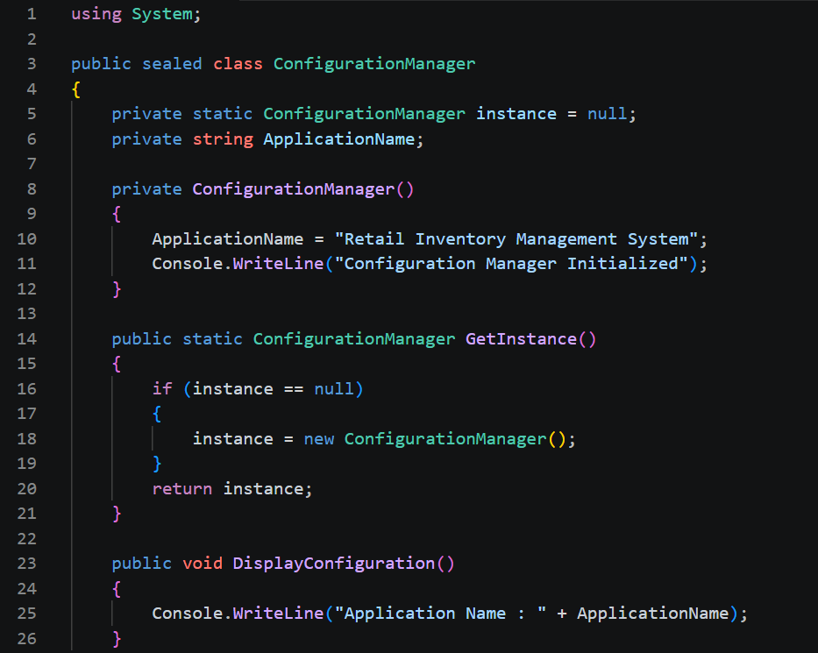
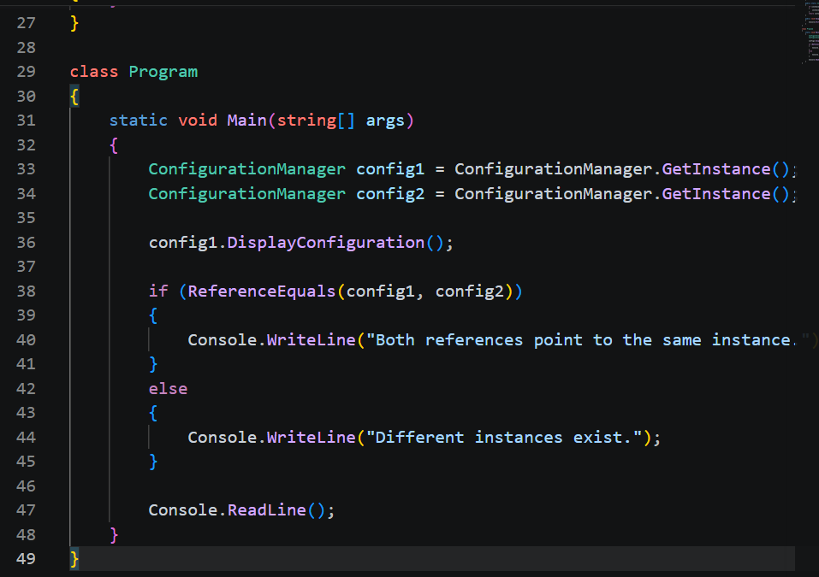
Output: -
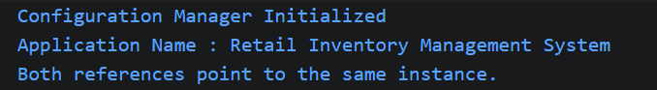
Advantages of Singleton Pattern:
• Prevents duplicate object creation.
• Conserves system resources.
• Provides centralized control over shared data.
• Easy to implement and maintain.
• Improves consistency across modules.
Conclusion:
The Singleton Design Pattern was successfully implemented to ensure that only one instance of the Configuration Manager exists within the application. The solution demonstrates how shared resources can be efficiently managed while maintaining consistency and reducing memory overhead. This pattern is particularly useful in enterprise applications where centralized access to configuration data, logging services, or database connections is required.

